Admin Guide:

**Admin Page – https://www.website_url.com/admin**

Login with your username and password

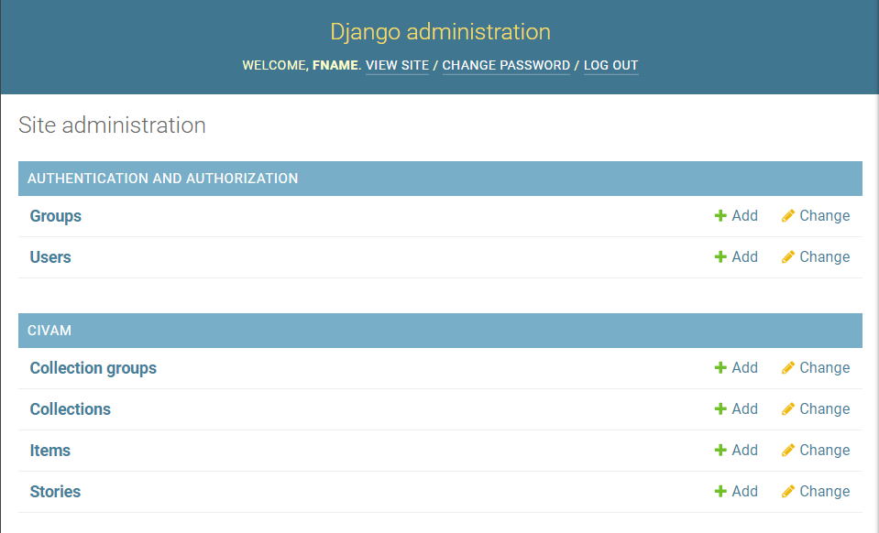

**Authentication and Authorization**

1. Groups – Collections of people who have permissions to view items, collections, and do other tasks
2. Users – Each user that has an account on the site

**CIVAM**

1. Collection groups –
2. Collections – Each collection on the site
3. Items – Each item on the site
4. Stories – Each user’s story on the site

To Add or Edit anything just click the database it is in, then choose the specific item to change, and then changes can be made from the following page

Map Guide – Example Crow Material Around the World

For Full Documentation of Awesome-Tables go to: <https://support.awesome-table.com/hc/en-us>

Using Google Sheets Make a spreadsheet with all the information you have

Required info: Latitude, Longitude

Add row below title for Map keyword data

CategoryFilter: Select with options

MapsTooltip: Will make a html editable tag to display info on map

HyperlinkType: add hyperlink

MapsLat/MapsLong: Lat and Long of location

More Found in Documentation

User Guide:

**Links**

1. /: Home Page
2. /register: Create a new user on the front-end
3. /user/login: Login Page
4. /collections: All Collections
5. /collections/new: Add new collection
6. /collections/<collection_id>: View specific collection
7. /collections/<collection_id>/new: Add new item to collection
8. /collections/<collection_id>/<item_id>: View specific item in collection
9. /collections/<collection_id>/groups: View groups associated with collection
10. /collections/<collection_id>/groups/new: Make new group for collection
11. /collelctions/<collection_id/groups/<group_id>: View specific group on collection